​​​​​​​​​​​​​​​
Events Slider
is a SharePoint APP that helps you to organize events in your company.

If you have needs to manage events like knowledge sharing sessions or sports activities Event Slider is the best assistant.
You can control capacity of your event, attach surveys, invite guests. Statistics if attendance will help you to analyze the event and determine the most successful one.
The APP has many features like:
- Event has key image that allows easily recognize event;
- Every event can hold more information than in standard events list;
- All history of events in your company presented in one place;
- Ability to join event and bring guests to event;
- Ability to join a standby list if all places are filled and receive notification when free seats are available;
- Filtering events by category and by date;​
- Informative notifications;
- Advanced survey can be attached to event;
- Handy statistics of attendance;
- Flexible permissions management;
- Create private events for limited amount of users;
- Controlling event capacity;
- Event can be added to your calendar;
- It runs completely within SharePoint - ALL DATA IS STORED IN SHAREPOINT LISTS!
- Import/Export of events.

Content
Content 2
App Part Functionality Overview 3
There are two App Parts: 3
There are two view types of events slider: 3
Slider uses ​​​​SharePoint similar ​​​​interface. So users will learn how to use it faster: 4
Event actions: 4
Working with App 5
Categories adding 5
Events adding 5
Copy existing event 8
Working with slider 9
Filtering by categories 9
Filtering by date 10
How to join event, bring friends to event 11
Meeting request, subscription and communication with participants 13
How to view all responses 15
​​Administrator Guide 19
Placing Events Slider App Part on the page. App Part Configuration 19
Configure Host page to open event by copied link 21

App Part Functionality Overview

There are two App Parts:
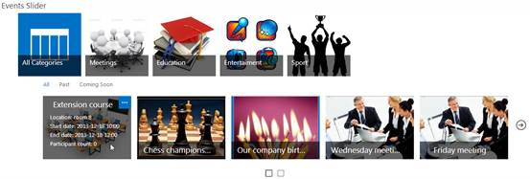
​​ 1. Events Slider App Part. Shows organization's events. There are several view types of the slider, filter controls, actions, settings which provide a lot of opportunities to use and configure this App.
2. Events ​​Slider Statistic App Part. Shows statistics of visiting of events. Users could see colleges have attended events at a given time period.

There are two view types of events slider:
Carousel Slider view type
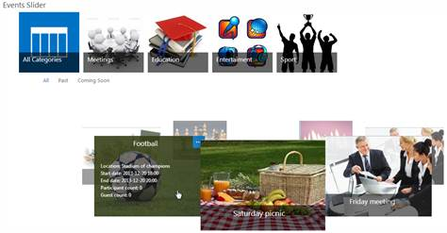

Simple Slider view type

Slider uses ​​​​SharePoint similar ​​​​interface. So users will learn how to use it faster:
​Filter control:
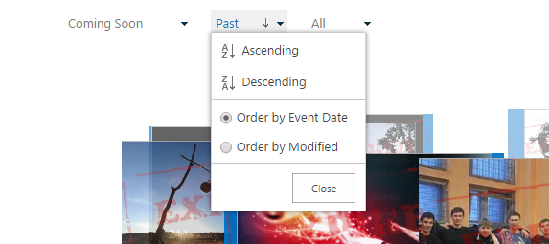

Event actions:
​
- View statistics (is shown only after someone joins)
- Answer questions (is shown only if there are some questions)
- Save Outlook appointment
- Edit event
- Contact participants
- Subscribe to notifications
- Copy link of particular event

Working with App

Categories adding
1. Go to the App page and choose Categories list at the bottom of the page.
2. Click "new item" in the list view or on the ribbon in the "Items" tab.
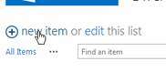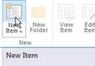
3. Fill in the information about new category and click “Save”

Events adding
1. Go to the App page and choose Events list at the bottom of the page.
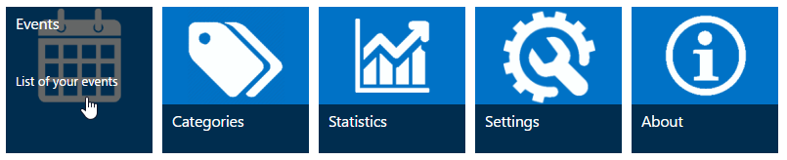
2. Choose the period of time on the calendar when the new event will occur and click "Add". Or click "New Event" on the ribbon in "Events" tab.
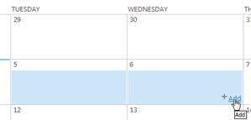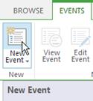
3. Fill information about the new event and click "Save".
​ 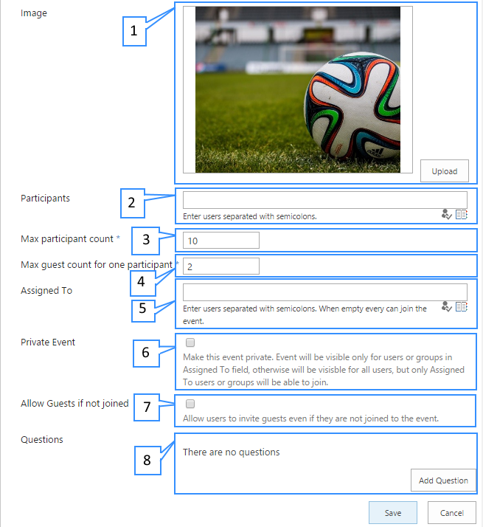
​Fields description:
- This image will be shown on the slider. If you leave this field blank then category image will be shown instead.
- Your company employees invited to the event
- Maximum guest count which your employee can invite to this event.
- The maximum amount of persons (participants and their guests) that can join this event.
- List of users who can join the event.
- Check if you want to show your event only for users specified in Assigned To field.
- Check if you want to allow users to invite guests even if they are not joined themselves.
- You can add questions to events and every user should answer these questions when joining.
If you want to add questions to event click “Add Question” button. You can add many questions for every event.
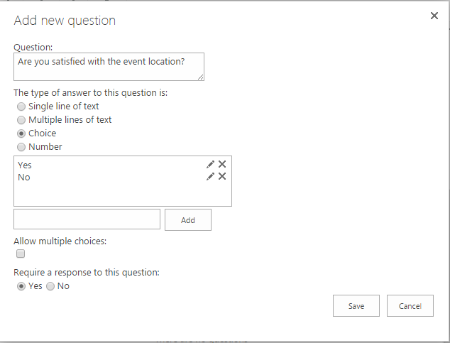​
If you would like to add dependencies between questions click to "Configure branching" button around parent question.
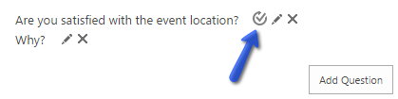
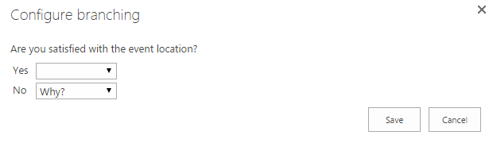

Copy existing event
Often some events are very similar. So you can copy existing event, change some fields and save the result as a new event.
To do this, select copying event and click on “Copy event” button on the ribbon.
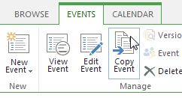

Working with slider

Filtering by categories
If you click on a category only events with chosen category will be shown in the slider.
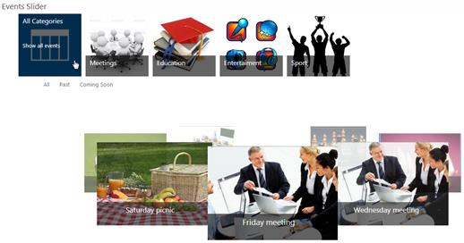

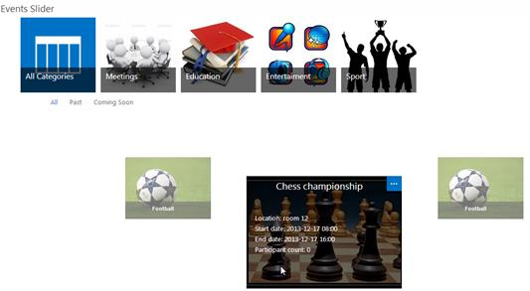

Filtering by date
You can click on “All”, “Past” and “Coming soon” filters to see only those events which start date satisfies this filter:
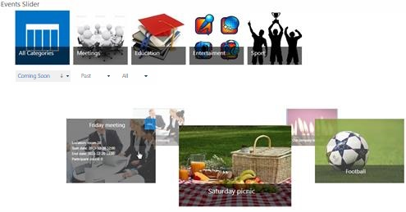
Also, you could change the ordering of the events:
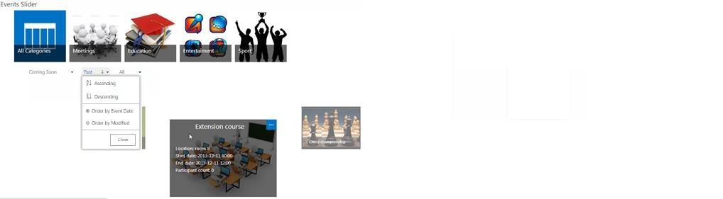​​​​

How to join event, bring friends to event
- You can click "View details" to view more information about an event;
​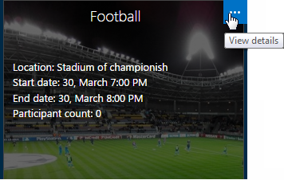
- Popup will be shown where you can join/unjoin, bring your guests to the event;

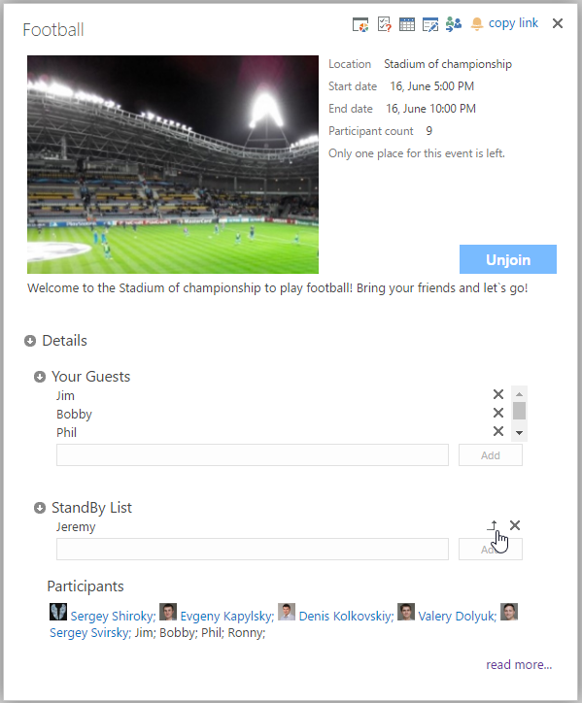
- If there are no free seats available, you can add yourself or your guests into standby list:
  - For SharePoint users
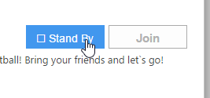
  - For guests

- If you or your guest is in standby list, then you will receive email notification when someone leaves the event;
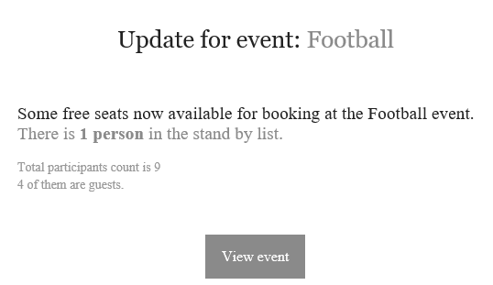
- To migrate from standby list to main list (if there are free places):
  - For SharePoint users – simply click “Join”
  - For guests – click “Move to Guests” near the guest

- If there are some questions, added to this event, after clicking on “Join” button you should answer to them.
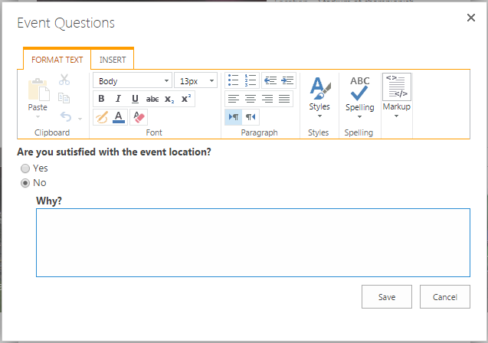

Meeting request, subscription and communication with participants

1. How to subscribe to event updates:
Click on Subscribe button on the event details popup
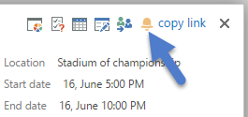
And you will get information about all updates of the event​
​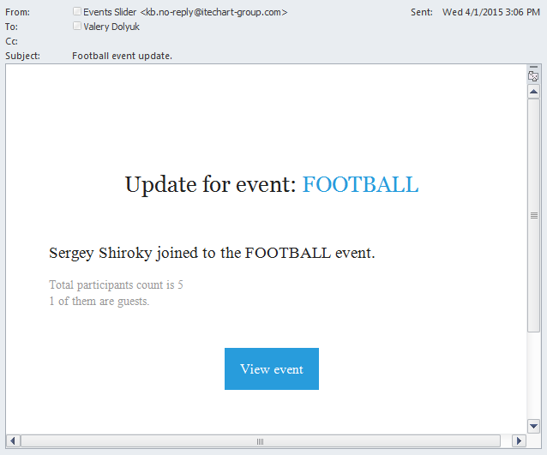​

2. How to quick send a message for all participants:
​​Click on "Contact participants" button on the event details popup​
​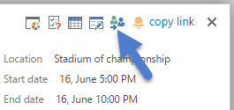
And write an email to all Participants of the event.​
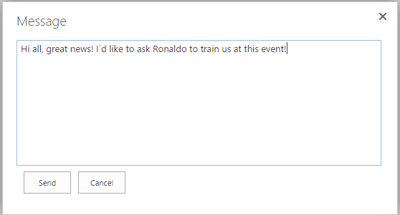

How to view all responses
​
Click on Statistics link
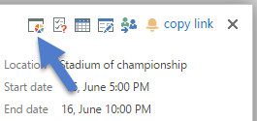
You could see survey statistics using chart view and bars view:
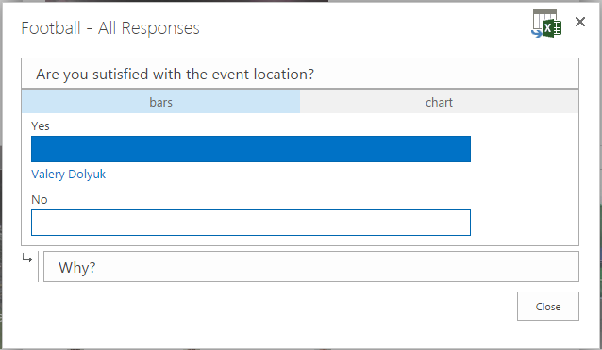
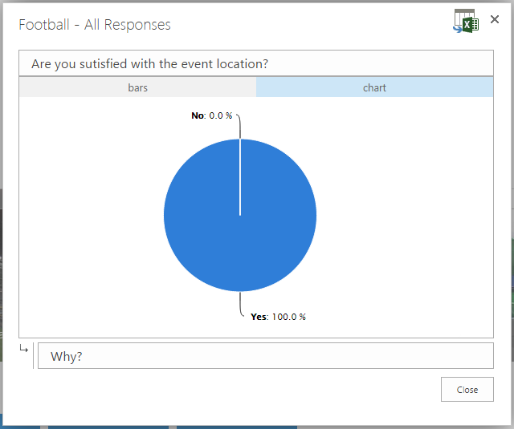
In addition, App provides an opportunity to export all responses to Excel
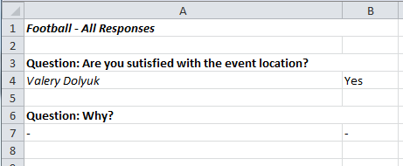

Statistics App Part
​​This App Part gives you an overview of all events and information about participants for each event. The user could easy select date range and events categories for display.
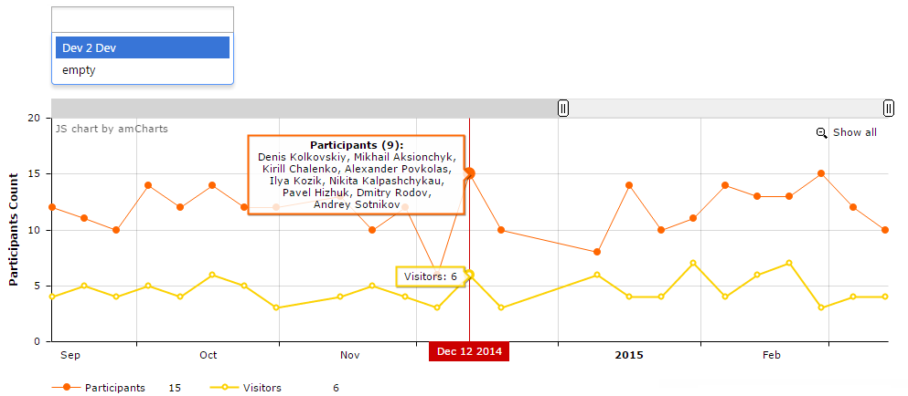
​​

Export/Import events.
​​App gives you the possibility to save your data and time. You could quick make a backup of your events with dependent data (participants, images, questions, etc.) or move items between instances of Event Slider App.
1. Go to Slider Settings page
2. a. Export events. Click on Export button and wait until process will be finished (progress bar and log panel help you follow the process):
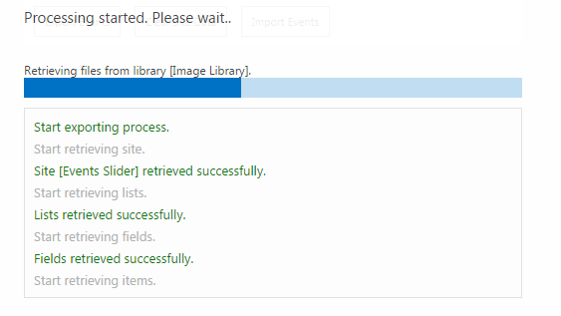
2. b. Import events. Click on Import button and wait until process will be finished:
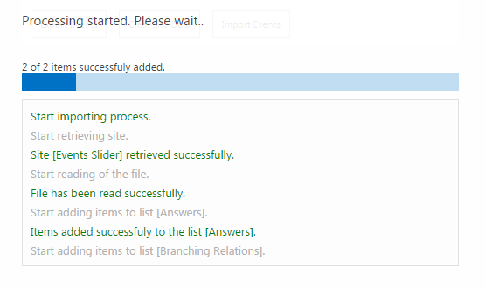

​​Administrator Guide

Placing Events Slider App Part on the page. App Part Configuration

After deploying Events Slider App Part to the site you could start to use it immediately on your page.
- Go to SharePoint page and add Events Slider App Part then add Events Slider Statistics App Part.
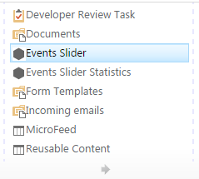
- You can edit Events Slider App Part properties. To do this click "Edit Web Part" in the drop-down menu in the upper right corner of the App Part.
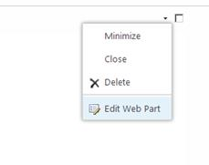
- Change properties and click “Apply” to preview changes or “Ok” to stop editing.​
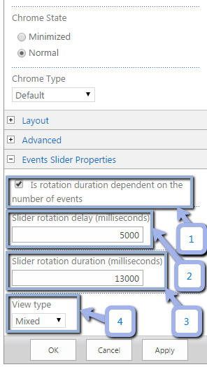
- If this property is checked, rotation duration will decrease when you increase the count of events;
- Duration of delay on each event;
- Slider rotation duration;
- Mixed:
  - If the count of events for display more than six slides, the simple view is used;
  - In any other case it uses carousel view.
View types:
- Carousel: shown events as rotated tiles;
- Simple: shown events in one line with paging.

Configure Host page to open event by copied link
If you want to use eventId query string parameter on Host to automatically open event inside App like this:
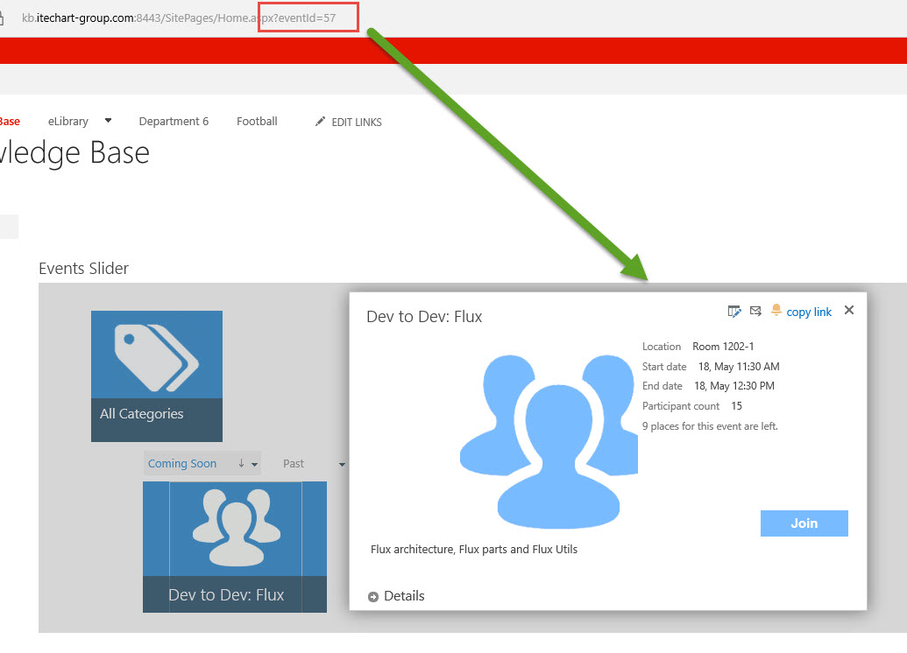
Then, you should add the special script to the page where Events Slider App Part is added (use script editor web-part). The script content:

